CNN-Based Stock Price Movement Prediction
Using Image-Based Market Data

FA690 Mini Project
Stevens Institute of Technology
March 2026

1. Introduction
This project implements the approach from "(Re-)Imag(in)ing Price Trends" (Jiang, Kelly, & Xiu, 2023), training a CNN to predict binary stock price movements from chart images. Rather than hand-crafted technical indicators, the model learns directly from raw pixel data. The objective is to predict whether a stock will go up or down in the next 5 trading days.
I implemented two CNN architectures: a simple baseline and an improved model with BatchNorm and LeakyReLU. Both were trained on 2000-2015 data and evaluated on held-out 2018-2019 test data.

2. Data Description

2.1 Dataset Overview
The dataset consists of 20-day stock price chart images and corresponding binary labels. Each image is a 64x60 pixel grayscale image that encodes the price movement and volume information of a stock over a 20-trading-day window. The label indicates whether the stock price increased (1) or decreased (0) in the following 5 trading days.
The data spans 20 years (2000-2019), with each year stored in seperate .dat (image) and .feather (label) files. Images are stored as memory-mapped arrays with dtype uint8, and labels are in Apache Feather format for fast I/O.

2.2 Data Statistics
The dataset contains approximately 1.5 million samples. Figure 1 shows samples per year and the positive class ratio.
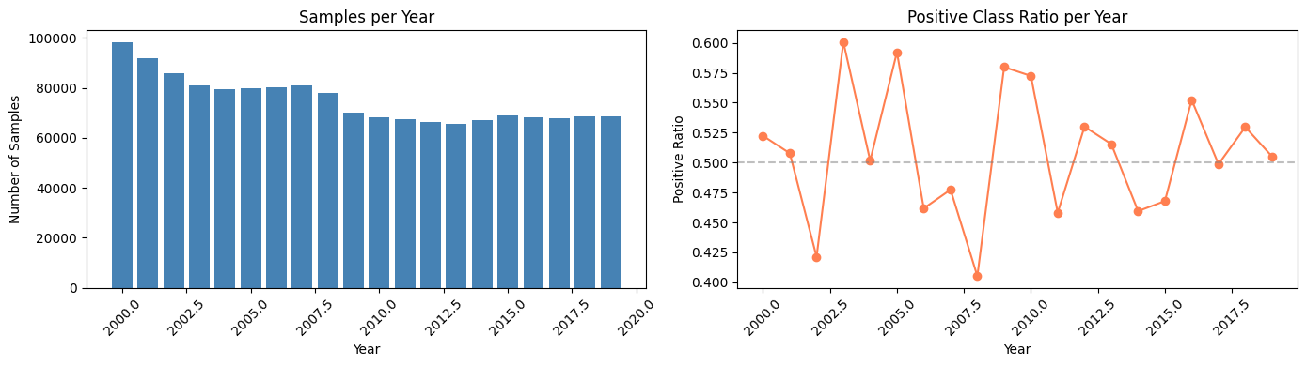
Figure 1: Number of samples per year (left) and positive class ratio (right)
Most years have a positive ratio between 0.42 and 0.60, roughly balanced around 50%. This establishes a 50% baseline for random guessing.

2.3 Sample Images
Figure 2 shows example chart images. Each contains price candlesticks in the upper portion and volume bars below.
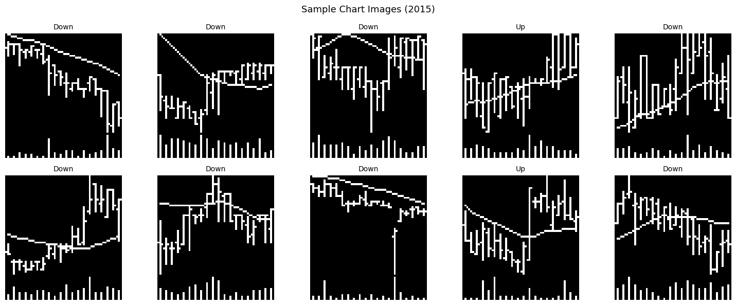
Figure 2: Sample stock chart images with their labels

2.4 Data Split
I used a time-series split to avoid look-ahead bias, which is critical for financial data. Using a random split would allow the model to "see" future data patterns during training, leading to overly optimistic results that dont generalize to real-world trading.
Split | Years | Samples | Purpose
Training | 2000-2015 | 1,229,006 | Model learning
Validation | 2016-2017 | 135,999 | Hyperparameter tuning
Test | 2018-2019 | 137,118 | Final evaluation

Table 1: Data split summary

2.5 Preprocessing
The raw pixel values (0-255, uint8) were normalized to [0, 1] by dividing by 255.0. This normalization is important becuase without it, the large pixel values can cause the loss function to behave poorly during training. Images were converted to PyTorch tensors with shape (N, 1, 64, 60) where 1 represents the single grayscale channel.

3. Methodology

3.1 Model Architectures
I implemented two CNN architectures to compare: a simple baseline and an improved version with several enhancements.

3.1.1 Baseline CNN
The baseline model is a straightforward 3-layer CNN with no special techniques:
- 3 convolutional layers (16, 32, 64 filters) with ReLU activation and max pooling
- A fully connected layer (64*8*7 = 3,584 inputs to 128 neurons)
- Dropout of 0.5 for regularization
- Sigmoid output for binary classification
- Total parameters: 482,305

3.1.2 Improved CNN
The improved model adds several techniques commonly used in modern deep learning:
- 4 convolutional layers (32, 64, 128, 128 filters) with LeakyReLU activation
- BatchNorm after each convolutional layer, which stabilizes training by normalizing intermediate activations
- LeakyReLU (slope=0.1) instead of ReLU to prevent the dying neuron problem
- Lower dropout (0.3) since BatchNorm already provides regularization
- Fully connected layers: 1,536 to 256 to 64 to 1, with BatchNorm on each
- Total parameters: 651,585

Feature | Baseline CNN | Improved CNN
Conv Layers | 3 | 4
Activation | ReLU | LeakyReLU (0.1)
BatchNorm | No | Yes
Dropout | 0.5 | 0.3
Parameters | 482,305 | 651,585

Table 2: Architecture comparison

3.2 Training Setup
Both models were trained with the following configuration:
- Optimizer: Adam with weight decay (L2 regularization)
- Loss function: Binary Cross-Entropy (BCELoss)
- Learning rate scheduler: ReduceLROnPlateau (factor=0.5, patience=3 epochs)
- Early stopping with patience=5 to prevent overfitting
- Batch size: 64

The baseline was trained with lr=0.001 for up to 20 epochs, while the improved model used lr=0.0005 for up to 30 epochs. The lower learning rate for the improved model helps with more careful optimization given its deeper architecture.
Training was performed on a Google Colab GPU (NVIDIA T4). The baseline early-stopped at epoch 11 with best validation loss of 0.6904, and the improved model early-stopped at epoch 6 with best validation loss of 0.6955.

4. Results

4.1 Model Comparison
Table 3 shows the test set performance for both models on the 2018-2019 held-out data (137,118 samples).
Model | Accuracy | Precision | Recall | F1
Baseline CNN | 0.5191 | 0.5254 | 0.7283 | 0.6105
Improved CNN | 0.5168 | 0.5340 | 0.5182 | 0.5260

Table 3: Test set performance comparison
The baseline's higher F1 (0.61 vs 0.53) is misleading. With 72.8% recall, it simply predicts "Up" for most samples rather than learning to discriminate. The improved model's balanced precision (53.4%) and recall (51.8%) show it actually distinguishes between classes, which is preferable for practical trading despite the lower F1.

4.2 Training Curves
Figure 3 shows the training and validation loss/accuracy curves for both models.
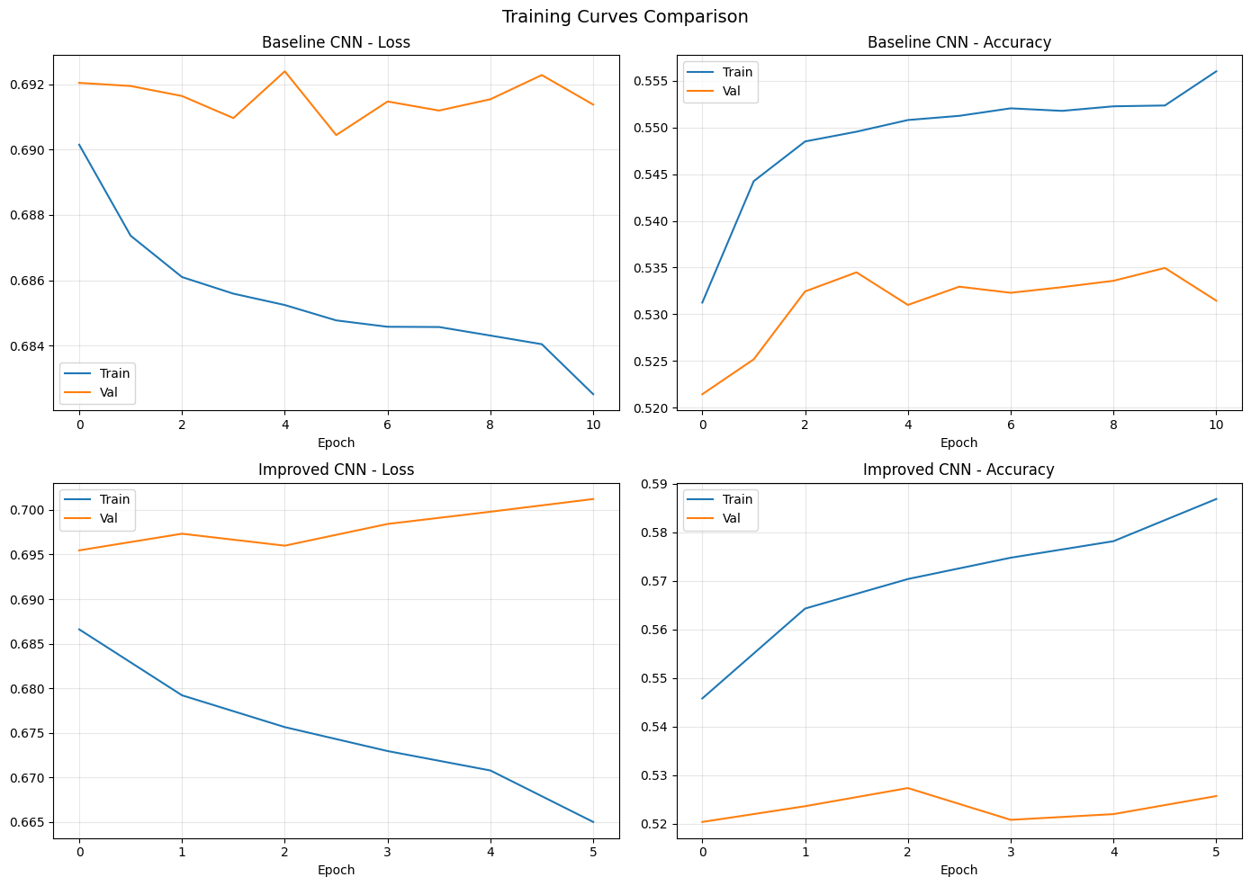
Figure 3: Training and validation curves for both models
The baseline shows relatively stable training with a small gap between train and validation curves, suggesting limited overfitting but also limited learning. The improved model shows a wider gap between training and validation accuracy, indicating it has more capacity to fit the training data. The early stopping mechanism prevents excessive overfitting by halting training when validation loss stops improving.

4.3 Confusion Matrices
Figure 4 shows the confusion matrices for both models.
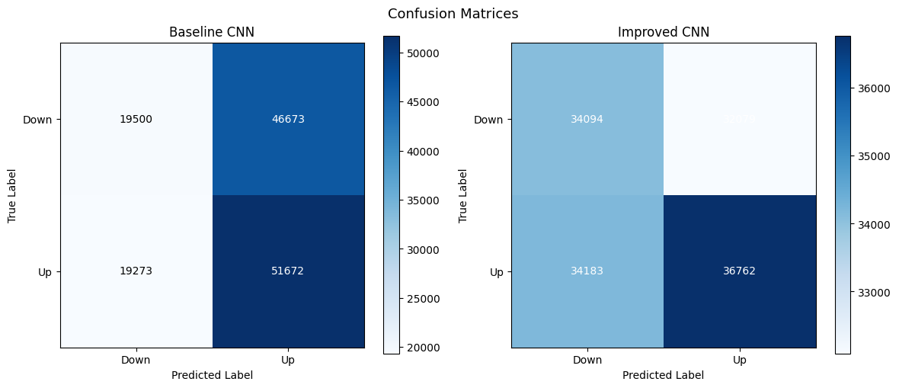
Figure 4: Confusion matrices for Baseline (left) and Improved (right) CNN
The confusion matrices clearly illustrate the behavioral diffrence between the two models. The baseline's matrix is heavily skewed toward predicting "Up", while the improved model's predictions are more evenly distributed across both classes.

4.4 Prediction Probability Distributions
Figure 5 shows how the predicted probabilities are distributed for actual up and down samples.
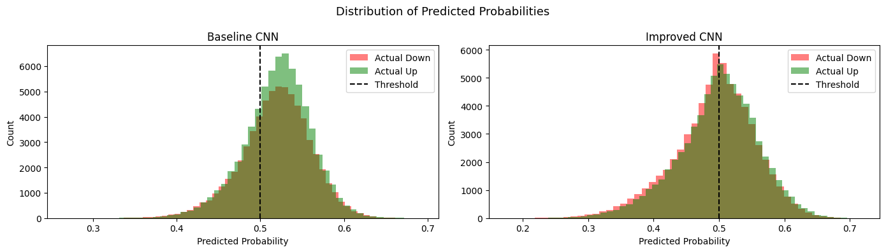
Figure 5: Distribution of predicted probabilities for both models
The baseline's predictions are concentrated above 0.5, confirming its bias toward predicting "Up". The improved model shows a more symmetric distribution, with the predictions of both classes overlapping significantly around the 0.5 threshold. This heavy overlap reflects the inherent difficulty of the prediction task.

4.5 Hyperparameter Experiments
I tested three different configurations of the improved model to examine the effect of learning rate and dropout. Each config was trained for 15 epochs.
Config | Learning Rate | Dropout | Best Val Loss | Test Acc | Test F1
A | 0.001 | 0.5 | 0.6899 | 0.5150 | 0.5928
B | 0.0005 | 0.3 | 0.6949 | 0.5163 | 0.5965
C | 0.0003 | 0.2 | 0.6970 | 0.5191 | 0.5539

Table 4: Hyperparameter experiment results
All three configurations achieve very similar test accuracy (51.5-51.9%), suggesting that the performance ceiling for this task is around 52% regardless of hyperparameter choices. Config A with higher learning rate achieved the best validation loss (0.6899) but early-stopped at epoch 9 due to overfitting. Config C with lower learning rate and lower dropout showed the largest train-validation gap, indicating that less regularization leads to more overfitting even with a slower learning rate.

4.6 Misclassification Analysis
I examined the improved model's predictions on the 2018 test data (68,481 samples) to understand where it fails.
Out of 68,481 samples, the model correctly classified 35,225 (51.4%) and misclassified 33,256 (48.6%). Among the misclassified samples: 18,329 were actual Up stocks predicted as Down, and 14,927 were actual Down stocks predicted as Up. The model misses more upward movements than downward ones, suggesting that some bullish patterns in 2018 were not present in the 2000-2015 training data.
Figure 6 shows the most confidently misclassified examples, these are cases where the model was very sure of its prediction but got it wrong.
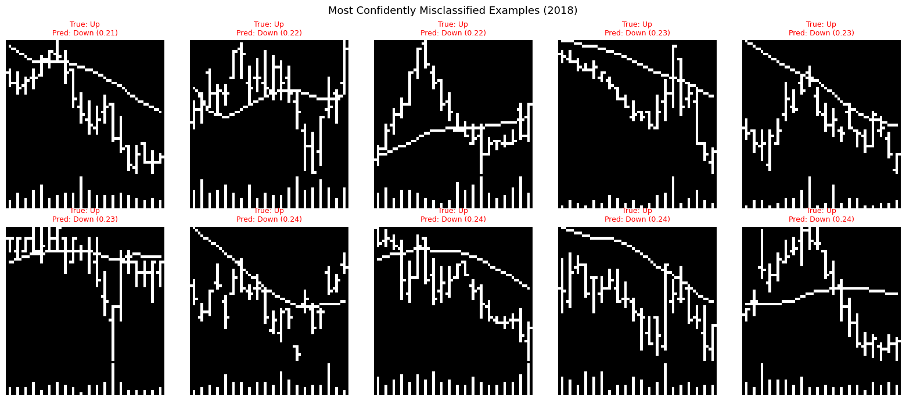
Figure 6: Most confidently misclassified examples (2018)
Figure 7 shows the most confidently correct examples for comparision.
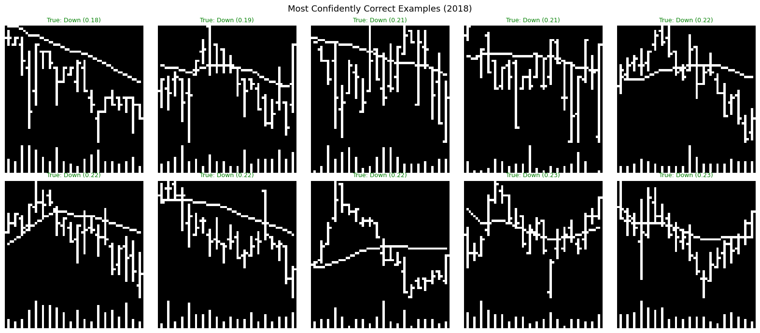
Figure 7: Most confidently correct examples (2018)
Comparing the two sets of images, the confidently correct predictions tend to show clearer trends (strong upward or downward slopes), while the confidently wrong predictions often show ambigous or conflicting patterns. This suggests the model has learned to identify strong directional trends but struggles with sideways or mixed patterns, which is a reasonable limitation.

5. Conclusion

5.1 Summary
In this project, I implemented and compared two CNN architectures for predicting 5-day binary stock price movements from chart images. The key findings are:
Both models achieve approximately 52% accuracy on out-of-sample data (2018-2019), which is consistent with findings in the academic literature. Stock prediction from chart images is an inherently low signal-to-noise task, and even small improvements over random guessing (50%) can be economically meaningful when applied across a large number of stocks.
The improved CNN with BatchNorm produces more balanced predictions compared to the baseline, which shows a strong bias toward predicting "Up". While the baseline's F1 score appears higher (0.61 vs 0.53), this is misleading becuase it results from prediction bias rather than genuine discriminative ability.
Hyperparameter experiments confirm that the accuracy ceiling is approximately 52% for this architecture and dataset, regardless of learning rate or dropout configuration. This aligns with the efficient market hypothesis, which suggests that historical price patterns contain very limited predictive information.

5.2 Limitations
- Only 20-day chart images were used. Incorporating additional features such as market cap, sector, or macroeconomic indicators could provide complementary information.
- The CNN architecture is relatively simple. More advanced architectures like ResNet with skip connections or attention mechanisms might extract better features.
- The fixed 0.5 classification threshold could be optimized using ROC analysis to find a better operating point.
- The model is trained once on 2000-2015 data. A rolling-window retraining approach could help adapt to changing market conditions over time.

